Name : Zain Khan

Roll:no: 24k-0509

Section : 3A

Task 1 by zain khan

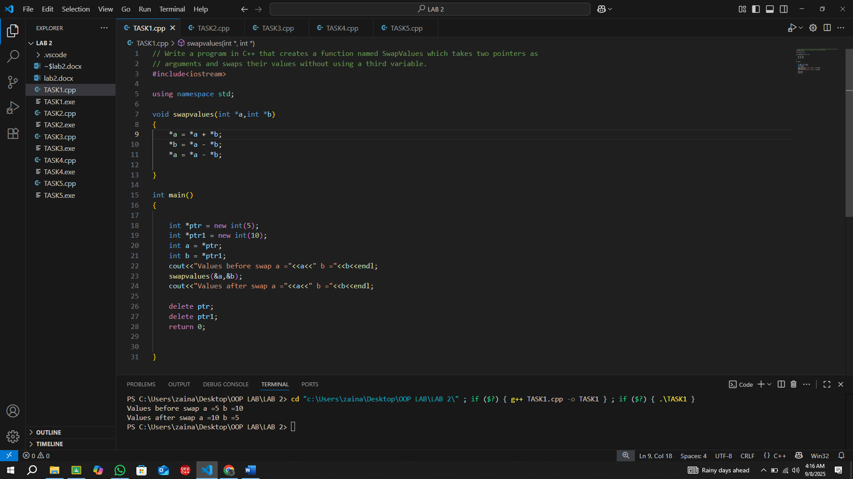

Task 2 by zain khan

Task 3 by zain khan

Task4 by zain khan

Task5 by zain khan

